Image | 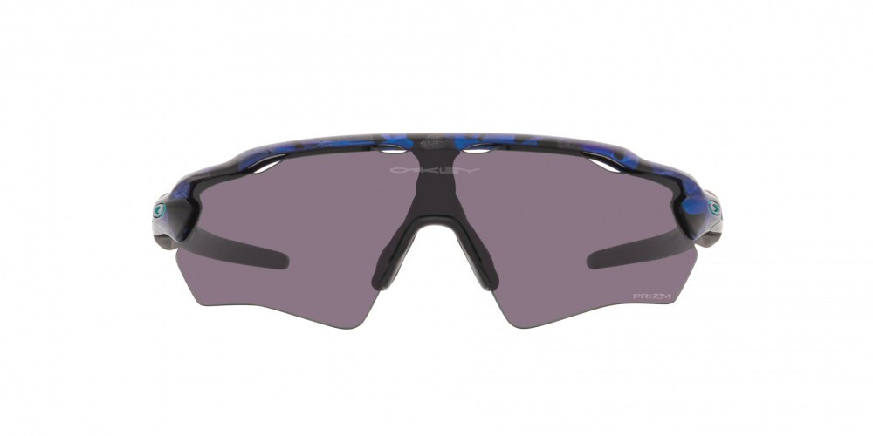
Brand | OAKLEY
Model Name | RADAR® EV XS SPIN-SHIFT
Price | RS 3999
PRODUCT DETAILS

